|  |  |
| --- | --- |
| A black video game controller  Description automatically generated  RetroConnector with microbmen’s Bluetooth Support Firmware  For Xbox controllers | Apple II Forever |

The RetroConnector is an amazing open-source project by ‘Option 8’. Contained within the project is Arduino code for connecting a USB Game HID ***wired*** game controller.

Recently code has been created to make use of ***wireless*** Bluetooth and allowing a Bluetooth gaming controller. The code has been loaded into the RetroConnector as ‘firmware’ on the ATMEGA328 chip.

Depending on which new firmware you have loaded into the RetroConnector, it can support PS4 type controllers OR Xbox type controllers, including some of the 8BitDo model controllers with Xbox support. The different controllers offer different ‘personalities’ described in this manual.

Details:

Bluetooth dongle support for RetroConnector  
<https://github.com/option8/RetroConnector/tree/master/Joystick%20Interface>

The Bluetooth radio used:  
Kinivo USB Bluetooth Adapter for PC BTD400  
<https://www.amazon.com/dp/B007Q45EF4?psc=1&ref=ppx_yo2ov_dt_b_product_details>

**Plug and Play for the RetroConnector**

Plug one end of the included 16-pin cable into the GAME port on the logic board of your Apple II. If your computer doesn't have a 16-pin port (e.g., Apple //c) use the optional 16-pin to 9-pin adapter by plugging one end of the 16-pin cable into the adapter, and the adapter into the 9-pin paddles/joystick port on the back of your computer.

Plug the other end of the 16-pin cable into the port on the RetroConnector Joystick Interface.

The 16-pin ribbon cable will have an indicator on one edge as to which is pin #1. Be sure that this edge lines up with the pin labelled #1 on the RetroConnector Joystick Interface board or look for the notch in the DIP16 port. This notch indicates the end where pins #1 and #16 are.

|  |
| --- |
| **DIFFERENT FIRMWARE IS SUPPLIED DEPENDING ON YOUR VERSION**   * PlayStation Firmware – supports PS4 and PS4 supported knockoff brands. * Xbox firmware – supports XBOX ONE S Model 1708, firmware version 3.1.1221. Microsoft allows downgrading of 1708 to 3.1.1221, and this firmware works perfectly. The Xbox firmware also appears to support 8bitdo controllers that support x-mode. i.e., hold X+Start to activate. * If you wish to support a different firmware, or you want chipsets for both firmware reach out to microbmen on Facebook’s “Apple II Enthusiasts Group” and there will be a small additional fee. |

**Connecting an Xbox One S Controller or an 8BitDo in X-Start Mode**

Works with Microsoft XBOX One S (Model 1708, firmware version 3.1.1221.0) controllers, and 8BitDO running in XBOX mode (X + Start). Works with 8BitDo Arcade Stick!!

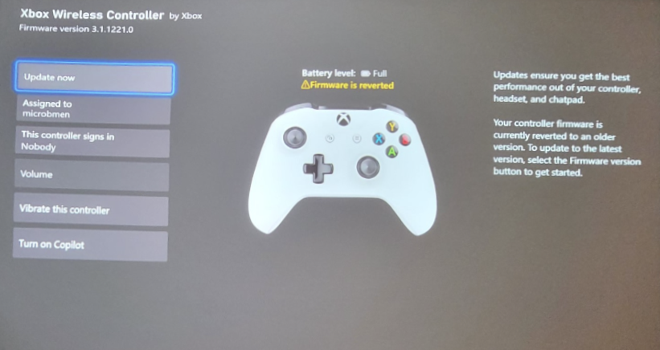

**After the controller is paired to the RetroConnector:**

Turn on the Apple with the RetroConnector plugged in. Then turn on the controller. Within a few seconds, they should connect.

**Pairing a new controller:**

Turn Trim adjustment fully clockwise (tighten) to place adapter into pairing mode.  Unplug/re-plug to reboot device.

Press the ’pairing’ + Xbox button for 3 seconds to put the controller into pairing mode. The LED should start blinking rapidly.

Once connected the controllers LED will turn solid to indicate it is connected.

Once paired and connected, turn trim to center the X/Y adjustment, and leave there, the adapter will connect to the paired controller each time. See the section on ‘calibration’ below.

Note: if the controller isn’t connecting ensure you have firmware 3.x and if needed revert the firmware using the Microsoft method published here:

<https://support.xbox.com/en-US/help/hardware-network/accessories/controller-firmware-reversion>

**About controls**

* 'View' button reverses Apple controller button 1 and 0.

Initial Buttons:

X/B/RB/LT = Button 0

Y/A/LB/RT = Button 1

* 'Menu' button turns on rumble for the LT/RT triggers.
* The Left Analog “L3” Button when pressed enabled the Left Analog stick ‘Corner Snap’ feature. Which makes the Top Left, Top Right, Bottom Left, Bottom Right areas of control snap into place. This makes the corners easy to find when playing. Very useful in games where diagonal control is important.
* The Right Analog “R3” Button when pressed enables the Right Analog stick ‘Stretch’ feature, which makes the right analog stick behave like the left analog stick in that it will ‘reach the corners’ and not be simply a circular analog control.
* 3 taps of Xbox home button disconnect the controller and shuts down.

The Xbox and most modern controllers offer at least 3 directional controls. One for digital control, and two for analog. The analog controllers offer a circular field of coverage on an X and Y axis. Using software, we are able to stretch that coverage for full range on an Apple II computer.

* The Left analog provides ‘stretched’ coverage to reach all the corners.
  + Press L3 enables ‘corner snap’ which makes corners easier to ‘find’.
* The Right analog provides natural values that make an analog circle (and provides more accuracy than the left ‘stretched’ analog)
  + Pressing R3 enables ‘stretched’ coverage for the right analog stick.
* The D-Pad is exact, Left/Right/Up/Down/Center

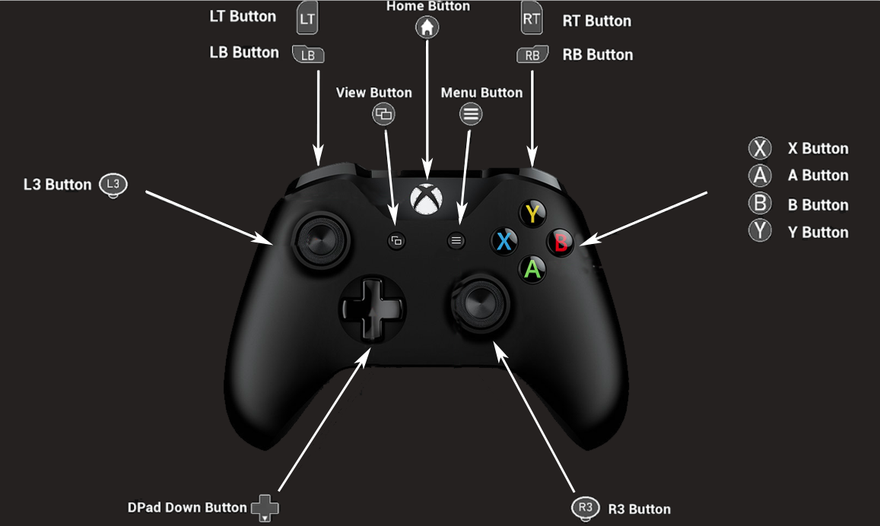

# Appendix

**Calibration**

This BASIC program is helpful in calibrating the RetroConnector Joystick Interface board. Type this in at the BASIC prompt on your Apple II:

10 print pdl(0) " " pdl(1)

20 goto 10

Then type RUN and hit enter.

While the resulting numbers scroll down the screen, use a small screwdriver to adjust the trim potentiometer (labeled "TRIM") so that the first two numbers are as close to 127 as possible. They may not be equal, so try to split the difference.

Most Apple II programs allow for a certain "dead zone" in the middle of the joystick values, so it's not necessary to be precisely 127 at center.

To test buttons along with joystick calibration, the above program can be adjusted so:

10 print pdl(0) " " pdl(1) " " peek(-16287) " " peek(-16286)

20 goto 10

The last two values are button 1 and 2. When pressed, they should be above 127, when released, below 127.